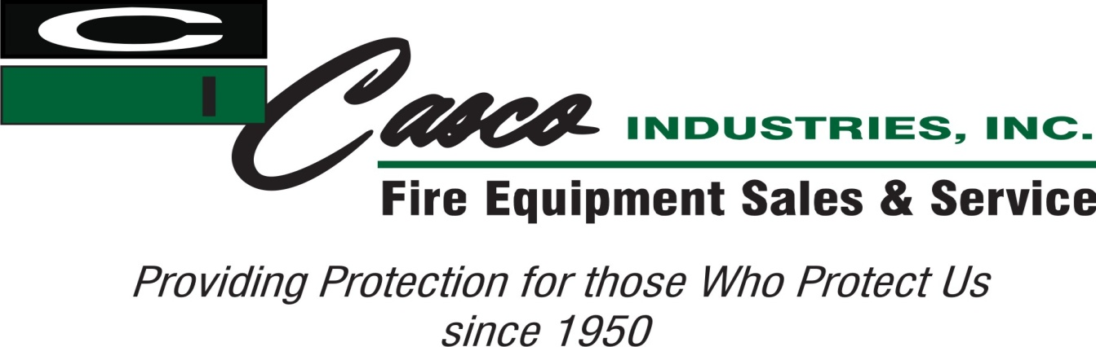

Outside Sales Representative

Date posted: September 26, 2025

Pay: Option 1: W2 With a Base plus commission Option 2 : 1099 at a higher commission rate

Job description:

Casco Industries is one of the largest distributors of Firefighting equipment in the United States. We are a family business based out of Shreveport, Louisiana and have been in business since 1950. Casco distributes anything a firefighter would wear or use (except for a firetruck). We are currently looking for a full-time or part-time salesperson that lives in the Kansas City, KS area. In order to be considered for this job you must have outside sales experience and/or firefighting experience! This position will be interviewed as both full-time or part-time depending on the candidate. That will then determine what salary and commission percentage is paid. Additional considerations that will improve chances of getting hired include sales experience, higher education, and computer skills.

Thanks for your consideration!

Job Type: Full-time

Benefits:

• 401(k)

• 401(k) matching

• Dental insurance

• Expense account

• Flexible schedule

• Health insurance

• Vision insurance

Compensation Package:

• Commission pay

Application Question(s):

• Do you have experience in the Fire Service?

Experience:

• Outside sales: 5 years (Required)

License/Certification:

• Drivers (Required)

Ability to Relocate:

• Kansas City, KS: Relocate before starting work (Required)

Willingness to travel:

• 75% (Required)

Work Location: On the road